3.Refer to the ECU diagram.
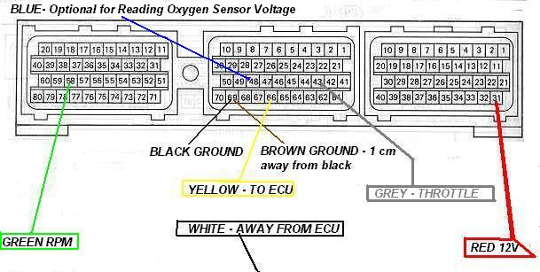

- Splice the Green Wire (RPM) into 58.
- Splice the Gray Wire (Throttle) into 43.
- Cut wire 66 in half, leave yourself enough room to connect a wire to ECU harness.
- Connect the Yellow wire to the 66 wire connected TO the ECU harness.
- Connect the White wire to the 66 wire heading AWAY from the ECU harness.
- Splice the Brown wire (ground 1) into 69, close to the ecu.
- Splice the Black wire (ground 2) into 69 at least 1cm away from the Brown wire.
- Splice the Red wire (12V+) in to ECU wire 31.
- Pink and Orange wires are not used.

